Winding Road Productions presents

### **Sunglasses at Night**

The 80-‘s Apocalypse

Sing Along Cabaret



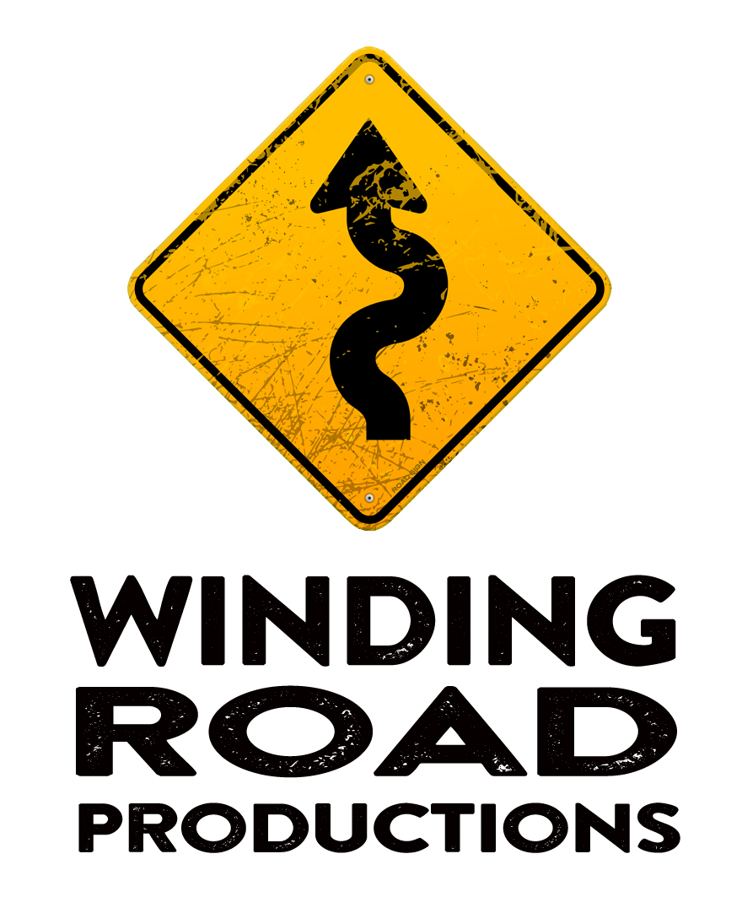

Contents

COMPANY PROFILE 3

ABOUT THE SHOW 4

PERFORMANCE SPECIFICS 6

MARKETING 7

PRODUCTION DETAILS 9

CONTACTS 10

# FinalLogo1

Performing Arts venues of Australia, hello!

Melissa Langton & Mark Jones welcome you to our company, Winding Road Productions.

Melissa and Mark have been touring Australia with cabaret shows, musicals and plays for 25 years!

From Colac to Cairns.

From Port Macquarie to Port Hedland.

We’ve played everywhere man.

We’ve clocked up the frequent flier points and have certainly hired a few Mini-vans in our time!

Many of the venues who’ve hired us over the years have asked

“Great! What else do you have for us? Are there other shows you can recommend?”

The answer to that question is definitely yes!

We’re often see shows that we think would be perfect for touring and we've decided it's time we brought them to your attention.

This brochure is brimming with brilliant performers from the world of music theatre, cabaret, opera and comedy with product ready to tour.

All shows are available to book for either morning or evening shows, or both!  They’re ready to go, so all you need to do is email us on [melissa@windingroadproductions.com.au](mailto:melissa@windingroadproductions.com.au).

For more information check [www.windingroadproductions.com.au](http://www.windingroadproductions.com.au)

# 

# ABOUT THE SHOW & GERALDINE

## SHOW SYNPOSIS

The 1980’s wasn’t all parties, rah-rah skirts and side-ponytails.

It was the Cold War. Chernobyl. The Berlin Wall. And the best

‘poncing’ about in pop music history.

Enter a world of artsy, decadent 80’s pop music excess as your host

Geraldine Quinn gives you a crash course in apocalyptic 80s

- inviting you to sing along to gloriously pretentious hits of the era.

Inflate those luft balloons and pout to the tunes of Ultravox,

Spandau Ballet, Bonnie Tyler, Pat Benatar, Duran Duran

- and many more - as Geraldine Quinn digs through this fabulous

era to present a loving, parodic, hilarious and exotic interactive

cabaret like none other.

Lyrics, sartorial tips and dance moves supplied. Prizes for best pretentious Euro-centric 80s outfit. Grab your shades. Pop your trench coat collar - you have a date with GLAMOUR.

Oh. Vienna.

GERALDINE’S PERFORMANCE HISTORY

Rock comedy singer, writer and sparkle warrior Geraldine Quinn has been performing her award- winning original pop/rock cabaret all around the world for a decade.

Since winning Victoria’s Green Room Award for Best Emerging Cabaret Artiste in 2006, Quinn has continued to draw recognition and plaudits in Australia. New Zealand and The United Kingdom. Winning the Short and Sweet Cabaret competition in 2009, she went on to be highly commended for Best Cabaret at Melbourne Fringe, and was nominated for a Golden Gibbo Award at Melbourne International Comedy Festival and three Green Room Awards for her 2010 show Shut Up and Sing.

In 2011, she created The Last Gig In Melbourne, a unique suite of original songs inspired by the local live music scene.

Geraldine has appeared on ABC TV’s Spicks and Specks, Adam Hills Tonight, Upper Middle Bogan, True Story and Rockwiz. She has been a cabaret judge for Short + Sweet, Melbourne Fringe and the Green Room Awards.

Her covers show Sunglasses at Night: The 80s Apocalypse Sing Along Cabaret sold out in Melbourne and Perth and earned her a third Best Cabaret Artiste nomination in the Green Room Awards.

She currently acts as Cabaret Panel Chair for the Victorian Green Room Awards and released her sixth independent album Fox Poncing in early 2017. She has co-hosted Casey Bennetto’s Swingin’ Bella Christmas since 2014, performing alongside guests such as Paul Kelly, Deborah Conway, Tim Rogers, Rebecca Barnard and Eddie Perfect.

AWARDS AND NOMINATIONS

**2016** – Nominee Best Cabaret & Best Musical Direction (Could You Repeat That?) Best Original Songs (Fox Poncing), Best Cabaret Artiste (Body of work) – Green Room Awards (GRAs)

**2015** – Winner Best Cabaret -–New Zealand Fringe Festival – MDMA: Modern Day Maiden Aunt (4 nominations – Best Cabaret, Best Comedy, Best Stand Up, Outstanding Performer)

**2015** – Winner Best Cabaret Artiste – GRAs – MDMA: Modern Day Maiden Aunt (4 nominations – Original Songs, Best Writing, Best Cabaret Production and Best Cabaret Artiste)

**2015** – Nominee Best Cabaret Production - GRAs – All Out of Pride

**2014** – Nominee Best Music – New Zealand Fringe Festival (Stranger)

**2013** – Nominee Best Cabaret Artiste – GRAs (Sunglasses at Night: The 80s Apocalypse Sing Along Cabaret)

**2013** – Nominee Best Cabaret – Adelaide Fringe (You’re the Voice)

**2013** – Winner Weekly Award - Cabaret

**2013** – Adelaide Fringe Festival (You’re the Voice)

**2011** – Winner Golden Gibbo Award (You’re the Voice)

**2011** – Winner Original Songs – GRAs (You’re the Voice & Last Gig)

**2011** – Nominee Best Cabaret Artiste – GRAs (You’re the Voice)

**2011** – Nominee Best Cabaret Production – GRAs (You’re the Voice)

**2010** – Nominee Golden Gibbo Award (Shut Up and Sing)

**2010** – Nominee Best Cabaret Artiste, Production & Original Songs – GRAs (Shut Up and Sing)

**2010** – Highly Commended Best Cabaret Melbourne Fringe (Shut Up and Sing)

**2009** – Winner Short & Sweet Cabaret competition (Catchy Pop Tarts, developed into Shut Up & Sing)

**2006** – Winner Best Emerging Cabaret Artiste – GRAs (Bad Ambassador)

**2006** – Nominee Original Songs – GRAs (Bad Ambassador)

## **PERFORMANCE SPECIFICS**

## DURATION

1 Act of 60-75 mins

or

2 Acts of 40 mins each

20 minute interval

SUITABLE VENUES

This show can be performed in most venues (indoors or outdoors).

## MAXIMUM NUMBER OF PERFORMANCES PER WEEK

In a single venue – 6 performances per week

If travelling – 5 performances per week (as long as travel times do not exceed 4 hours)

## MINIMUM BREAK BETWEEN PERFORMANCES

90 minutes

## TOURING PERSONNEL

|  |  |
| --- | --- |
| Name | Role |
| Geraldine Quinn | Performer |
| Mark Jones | Musical Director/Pianist |

# 

# MARKETING

## MATERIAL

All material can be accessed in the Dropbox link below

<https://www.dropbox.com/sh/lg4o2b8bmqzokkn/AAAYJbcWoYw1E-KOAk44-vH-a?dl=0>

## MARKETING COPY

The 1980’s wasn’t all parties, rah-rah skirts and side-ponytails.

It was the Cold War. Chernobyl. The Berlin Wall. And the best

‘poncing’ about in pop music history.

Enter a world of artsy, decadent 80’s pop music excess as your host

Geraldine Quinn gives you a crash course in apocalyptic 80s

- inviting you to sing along to gloriously pretentious hits of the era.

Inflate those luft balloons and pout to the tunes of Ultravox,

Spandau Ballet, Bonnie Tyler, Pat Benatar, Duran Duran

- and many more - as Geraldine Quinn digs through this fabulous

era to present a loving, parodic, hilarious and exotic interactive

cabaret like none other.

Lyrics, sartorial tips and dance moves supplied. Prizes for best pretentious Euro-centric 80s outfit. Grab your shades. Pop your trench coat collar - you have a date with GLAMOUR.

Oh. Vienna.

## MEDIA QUOTES

“A brilliant blend of sass, satire and pathos, delivered with an electrifying voice that can strip paint off the walls or retreat into haunting vulnerability.” The Age *****

“Magnificent on-stage charisma [...] With ballsy attitude like she displays so convincingly here, she could always be a rock goddess instead. Chortle (UK) ****

“Excellent silly fun. No one wanted it to end” The Age

## VIDEO LINKS

Sunglasses at Night – Promo Video

<https://www.youtube.com/watch?v=kFuiQV-O-iQ>

Life On Mars

<https://www.youtube.com/watch?v=AkMnpxdsFio>

## MARKETING MATERIALS

All material can be accessed in the Dropbox link below

<https://www.dropbox.com/sh/lg4o2b8bmqzokkn/AAAYJbcWoYw1E-KOAk44-vH-a?dl=0>

## CONTENT WARNINGS / AUDIENCES TO AVOID

# 

# This show is not suitable for children 13 and under.

# PRODUCTION DETAILS

## TECHNICAL SUMMARY

LOADING DOCK

No access to a loading dock is required. If a piano or keyboard (upright or grand) is not available in the venue, a semi-weighted keyboard could be provided.

STAGING AND SET

Staging consists of a **data projector and screen** or access to a white cyclorama (centre stage), a keyboard or piano, 2 x vocal microphones onstage and 1 x DI (2 x DI if a keyboard is utilised). If PowerPoint cannot be managed via a USB remote from the tech desk area, will require power onstage for laptop (tagged and tested). Only furniture required is a small table or similar for small amount of props/laptop (if required). A maximum of 2 x music stands may also be required.

Minimal audio playback required (1 cue).

The above specs are dependent on the venue size/capabilities. When there is not a ceiling-mounted data projector pre-existing in the space, the location of the data projector and the breadth of projection is a consideration, as the projection is the central focus of the show. However this has been successfully worked around in a number of venues (e.g. Deluxe Spiegeltent and PO Box Theatre in

Ballarat) with minimal impact.

The minimum stage area is approximately 2.5 metres deep x 3.5m wide. The only

“special requirement” would be use of a data projector.

## CREW REQUIRED FROM VENUE

1 x Lighting Technician

1 x Stage Management

## STAGE

A stage of no less than 5 metres width, 3 metres depth and 30cm high.

Steps into the audience.

## LIGHTING

Basic cool and warm and white washes suffice for the production. A single technician can operate the show (in-house tech is fine) from the tech desk, and the data projector output is operated using a remote USB by the main artist (Geraldine Quinn) from the stage.

## SOUND

All sound to be supplied by the venue.

## WARDROBE

Venue to supply Iron and Ironing Board, and 2 dressing rooms

## FREIGHT NOTES

Keyboard Freight required if piano is not available at the venue.

# 

# CONTACTS

For all enquiries please contact:

Melissa Langton

Email

[melissa@windingroadproductions.com.au](mailto:melissa@windingroadproductions.com.au)

Phone

+61 412 561 291